Name : Pranit Tandon

Reg no - RA1911028010014

**AIM** :- To perform Static NAT Configuration using Cisco packet Tracer

**Component used**:-

|  |  |  |
| --- | --- | --- |
| Device | Type | Quantity |
| Device | Laptop  Server | 3  1 |
| Router | 1841 | 2 |
| Wires | Copper Straight Through  Copper Cross Over  Serial DCE | - |

**IP Configuration:-**

|  |  |  |
| --- | --- | --- |
| Device / Interface | Serial 0/0/0 of R2 | Connected With |
| Laptop0 | 10.0.0.10/8 | Fa0/0 of R0 |
| Laptop1 | 10.0.0.20/8 | Fa0/0 of R0 |
| Laptop2 | 10.0.0.30/8 | Fa0/0 of R0 |
| Server0 | 192.168.1.10/24 | Fa0/0 of R1 |
| Serial 0/0/0 of R1 | 100.0.0.1/8 | Serial 0/0/0 of R2 |
| Serial 0/0/0 of R2 | 100.0.0.2/8 | Serial 0/0/0 of R2 |

Diagram of Connection Performed on Cisco PAcket tracer:-

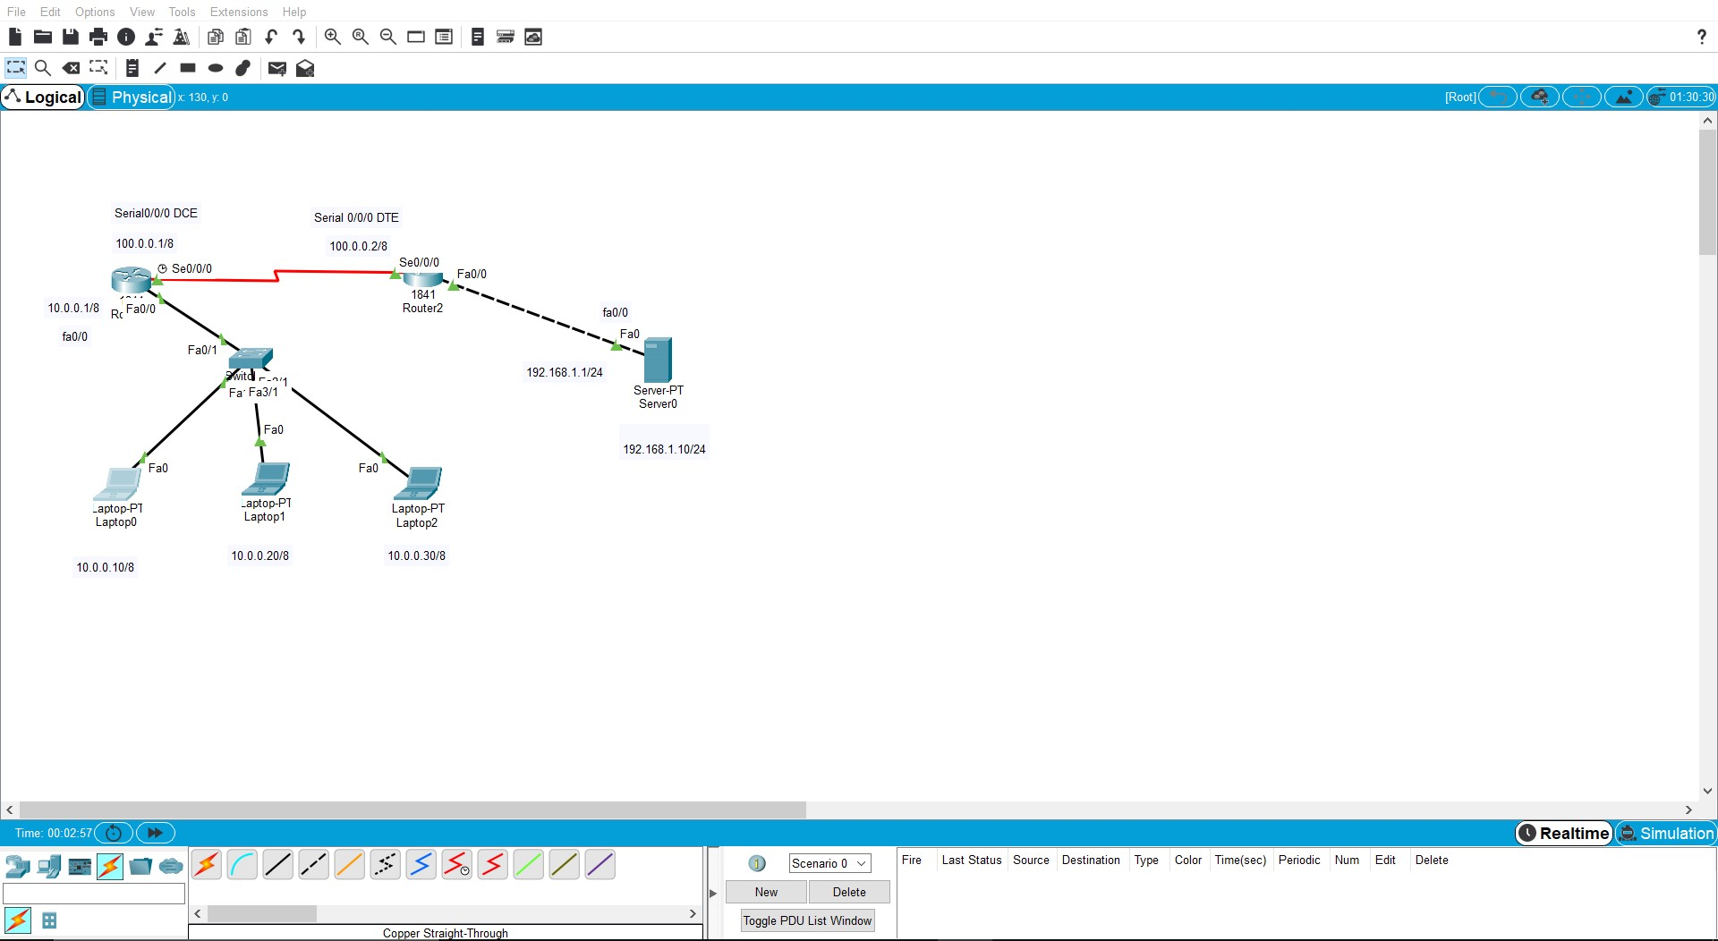

CLI Cmd :-

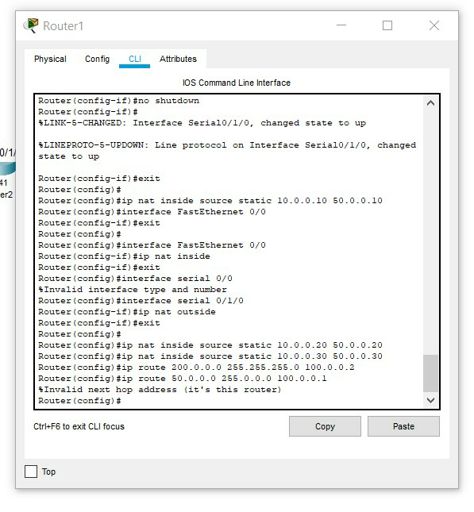

PIng Cmd:-

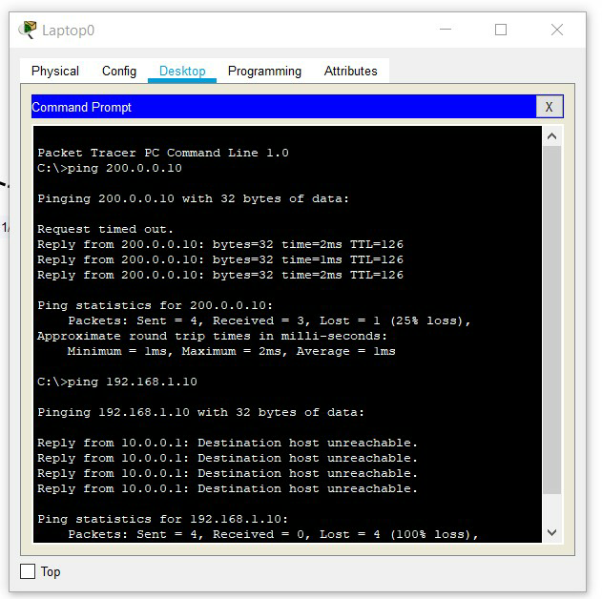

Result: -

Thus Static Nat Configuration is performed and successfully verified by using ping command